List 1 – matplotlib basics
If you will not finish during the classes, finish at home before next classes.
- Using matplotlib library try to recreate this chart
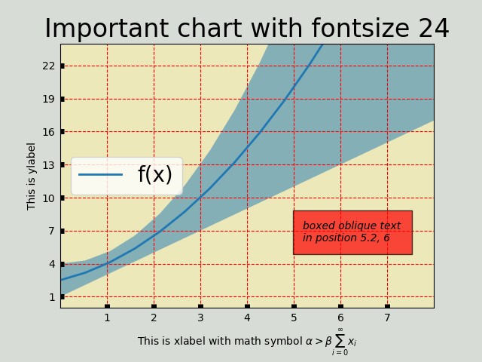
- Top line of blue area is given by formula
- Bottom line of blue area is given by formula
- Solid blue line is average of these two
- Ticks have width equal to 5

- Using matplotlib library try to recreate this chart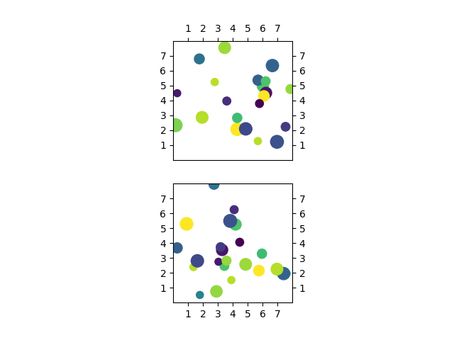
- You should randomly plot 24 points in the area (0,8) x (0,8) with random sizes (between 50 and 200) and color
- To randomize location you can use np.random.normal()
- To randomize size and color you can use np.random.uniform()
- Check have ticks are looking like on the picture
- Both charts are squares – set them like that in code, don’t adjust after plotting

